Scott Nidell

Lab 2 Notes

1000921465

CSE 2441-001

**Introduction:** Lab 2 is an introduction to Quartus II and Model Sim. Software that allows engineers to quickly create a digital design and test the outputs using a waveform generator file.

**Theory:** The First Part of Lab 2 develops a process on how to generate the first Quartus II project which is depicted below (Figure 1). The second part of the lab is to design a 2-bit full adder (Figure 2) and lastly create a module for that full adder to be used in latter labs.

**Figure 1:**

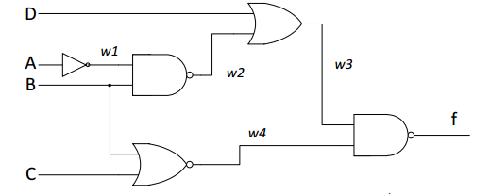

**Figure 2:**

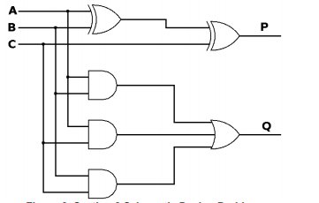

**Procedure:** The project wizard is used to create a barebones project with no associated files. Once the project is created a schematic/ I/O file is created. Gates are then inserted into the schematic file and wired up with the orthogonal wire tool. Once all required connections are made a waveform file is created to test the circuit (Figure 3)

**Figure 3: Captured waveform of first circuit**

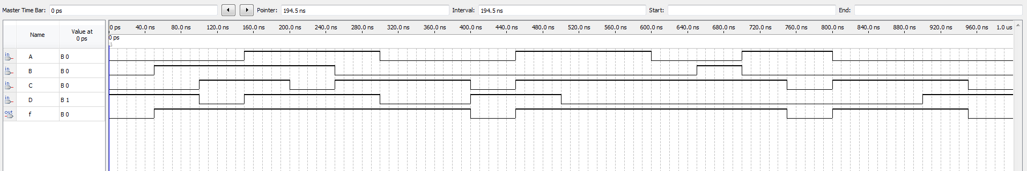

The second part of Lab2 is to implement a 2-bit full adder. Using the same procedure as part 1 of the lab the schematic is drawn in a schematic file and a waveform to test it is generated (Figure 4).

**Figure 4: Waveform of a 2-bit full adder**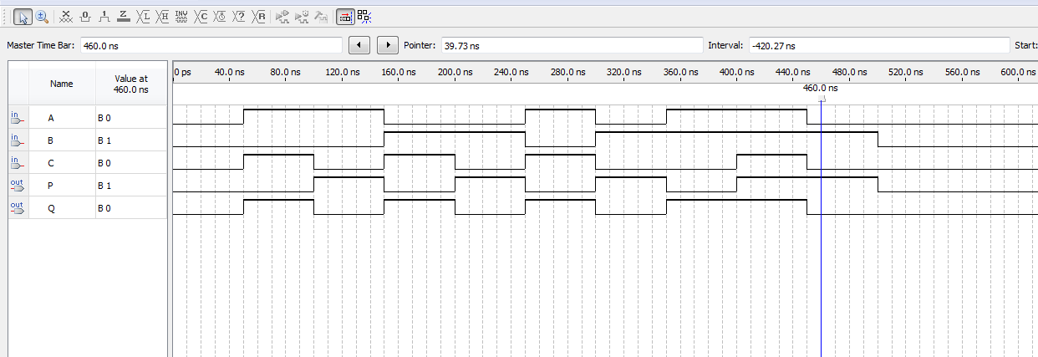

The third and last part of the lab is to create a component using the previous section two gate level schematic. This is done by using the Symbol creator function in Quartus II. Once a symbol is creator it can now be used as a single block in a new design (Figure 5).

**Figure 5:** A 4-bit full adder using the previously created component

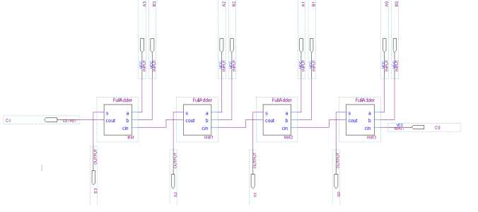

**Conclusion:** Overall the lab was successful. However, I did have an issue when I changed my design and the waveform output was not updating. I found that once the designed is changed it must be recompiled before a waveform file will produce new outputs.